|  |
| --- |
| Virtual Reality Laboratory in the Munroe Meyer Institute |
| cometrics |
| v1.3.0 User Guide |

|  |
| --- |
| Hurtz, Morgan L | Arce, Walker | Walker, Seth, PhD, BCBA-D  8-2-2022 |

**Contents**

|  |  |  |
| --- | --- | --- |
| Section 1: Open Program |  | 2 |
| Section 2: Start Menu |  | 4 |
| Section 3: Project Setup |  | 5 |
| Section 4: Keystroke File Setup |  | 7 |
| Section 5: Patient Information |  | 9 |
| Section 6: Session Times |  | 12 |
| Section 7: Keybindings |  | 13 |
| Section 8: E4 Streams |  | 16 |
| Section 9: Video View |  | 19 |
| Section 10: Quick Access Menu |  | 24 |
| Section 11: Keystroke File Format |  | 25 |
| Section 12: Interobserver Agreement Coefficients |  | 26 |
| Section 13: Session Output File Format |  | 28 |
| Section 14: Configuration Changes |  | 29 |
| Section 15: Understanding Webcam Order |  | 30 |
| Section 16: Modifying Keystroke Files |  | 31 |
| Section 17: Connecting External Input |  | 32 |
| Section 18: Reporting Bugs and Other Issues (GitHub) |  | 34 |
| Section 19: Woodway Split Belt Treadmill Support |  | 36 |
| Section 20: BLE Peripheral Support |  | 39 |
| Section 21: Review Mode |  | 42 |
| Section 22: Loading Previous Sessions |  | 43 |
| Section 23: Calculating E4 Metrics |  | 44 |
| Section 24: Sending Feedback |  | 45 |

**Section 1** Open Program

* 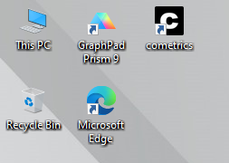 ==
* Locate the **cometrics** icon on desktop

OR

* Search “**cometrics**” in the Windows search bar (bottom left of screen)

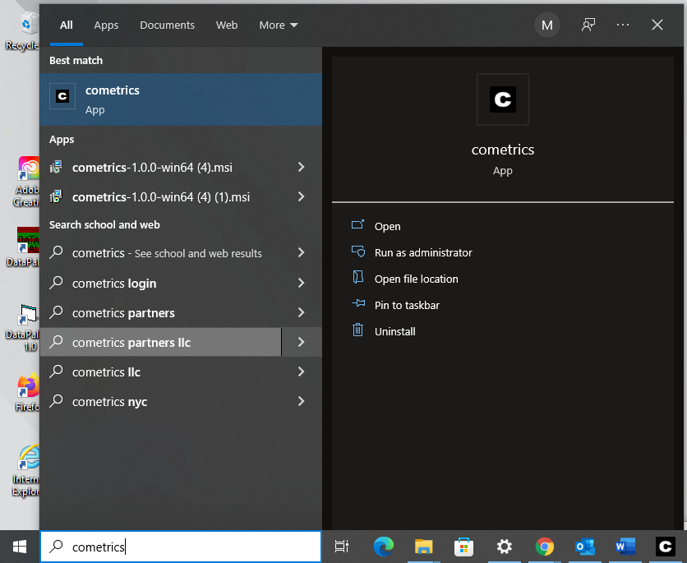=

**Section 1** Open Program

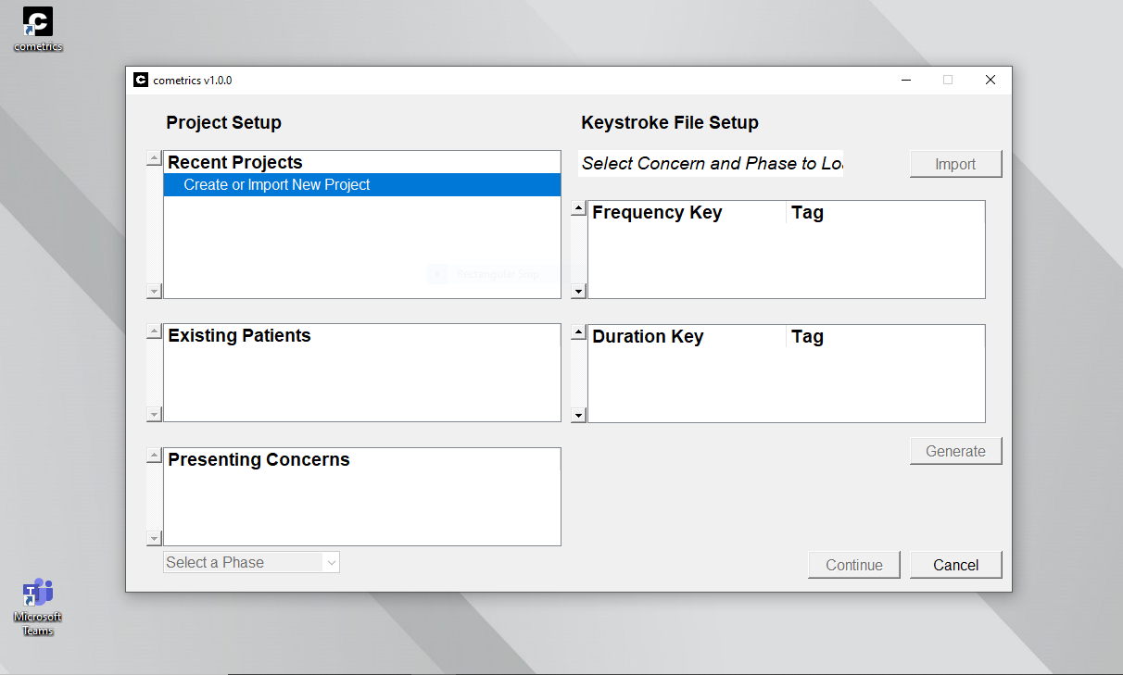



**Start Menu** will open

**Section 2**  Start Menu

**Two Sections of Start Menu:**

Project Setup Keystroke File Setup

Pressing **Create or Import New Project** will open the above window. The default save directory can be changed using the folder icon. Existing projects can be imported using the **Import** button

**Section 3** Project Setup



* **Recent Projects** tab is used for creating and importing projects
* **Existing Patients** tab shows which patient is being studied in each session
* **Presenting Concerns** tab shows what behaviors are being recorded / analyzed in the session

**Section 3** Project Setup

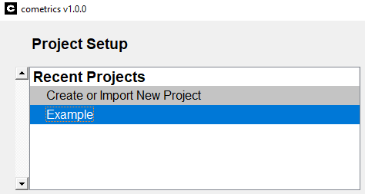

1. Create or import the session you wish to work on
   1. Right clicking a project will delete the project from the list

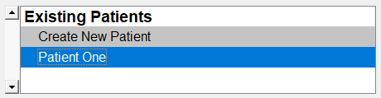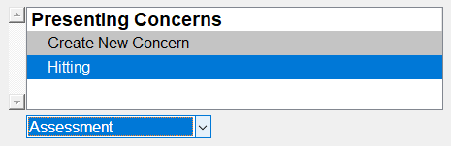

1. Create or select the patient being assessed
2. Create and add the presenting concerns in the session
3. Select whether this is an **Assessment** or **Treatment** phase

**Section 4** Keystroke File Setup



* This is done by **importing** an Excel spreadsheet associated with these codes
* If a file is not already uploaded, press **Import** to find and select the Excel file you wish to use for coding
* **Keystroke File Setup** is used to assign behaviors to keys when coding

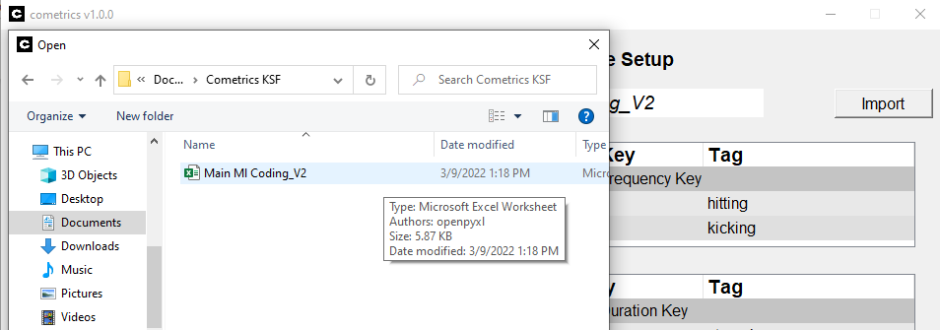

**Section 4** Keystroke File Setup

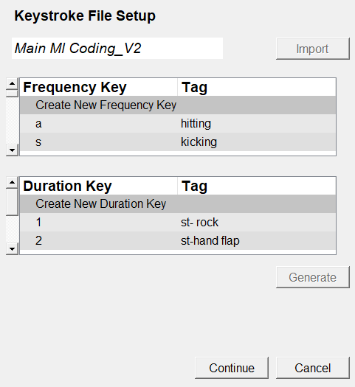

* Name of the selected Excel file
* Preview of the coding keys in the Excel file
* Select **Continue** in the bottom right to begin coding

**Section 5** Patient Information (Page 1)

**NOTE:** You will **not** be able to begin coding until all sections of **Patient Information** are complete (error messages will occur until the spaces are filled)

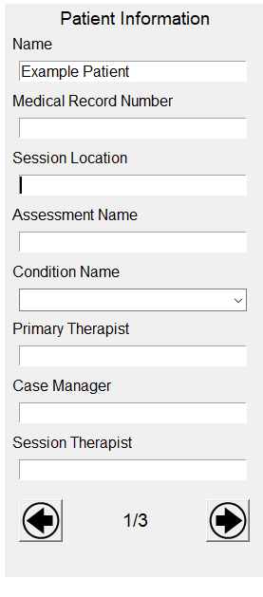

Induced stimulus that you are recording measures for

The name of the assessment

Where the session is happening

Unique identifier for patient

Name of case manager

* There are 3 **Patient Information** tabs

Name of session therapist

Name of primary therapist

Patient name

* Use the arrows to navigate the **Patient Information** tabs

**Section 5** Patient Information (Page 2)

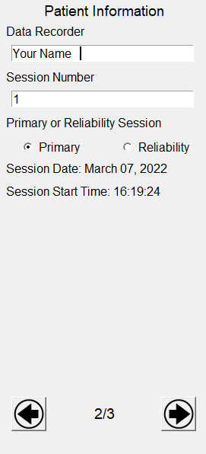

The date and starting time of the coding session

Identifying number for the session

Name of the person coding the video

Select if this is a Primary session (patient video) or a Reliability session (test for coder accuracy)

**Section 5** Patient Information (Page 3)

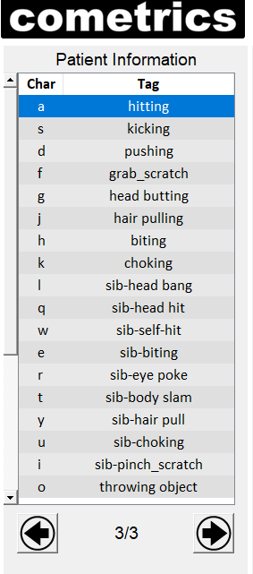

Page 3 of the **Patient Information** tab lists the keyboard characters assigned to each behavior tag

This will be automatically shown when the session is started

**Section 6** Session Times

**Section 7**  Key Bindings

Pause / Resume the session

Start / Stop the session

Enable to play a sound on an interval for discontinuous measurement strategies

Sets the total duration of the session

Enable to play a loaded video at double speed

Shows if session is Started **(green)**, Stopped **(red)** or Paused **(yellow)**

Used to go **Backward** in video by one second

Used to go **Forward** in video by one second

Used to **Play / Pause** video in video tab

Records the amount of time spent paused

Records the amount of time spent coding

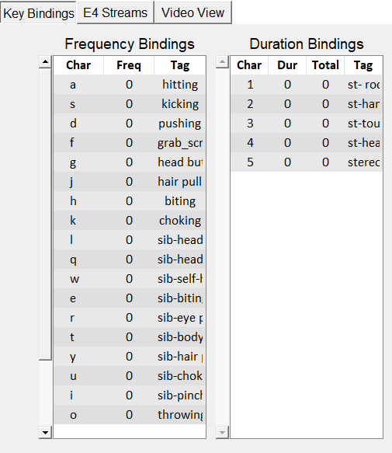

* The **Dur** and **Total** column records how long a code has been active per activation and per session, respectively
* The **Frequency** column shows the number of times a code has been used in the session
* The **Key Bindings** tab shows the **characters** tied to each behavior

**Section 7**  Key Bindings

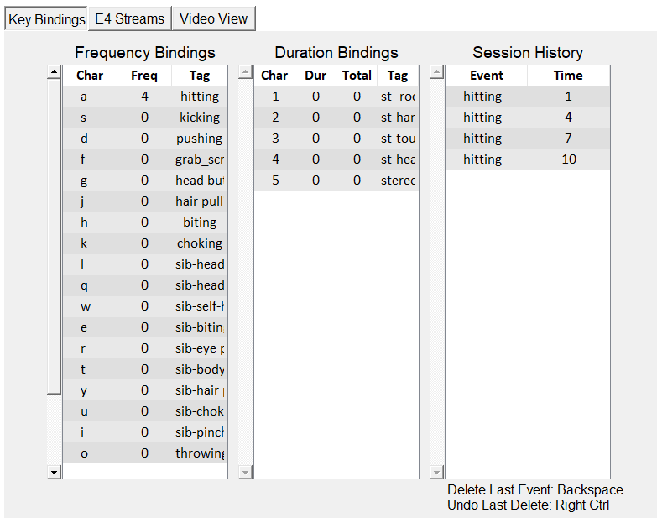

* Press **Backspace** to delete the last coded event
* Press the **Rightmost Control** key to undo the last deleted event
* The **Event** and **Time** columns show what behaviors have been coded during the session and at what time they occurred, respectively
* The **Session** **History** tab gives a basic view of what codes have been used and the time (in seconds) at which they occurred

**Section 7**  Key Bindings (Keyboard)

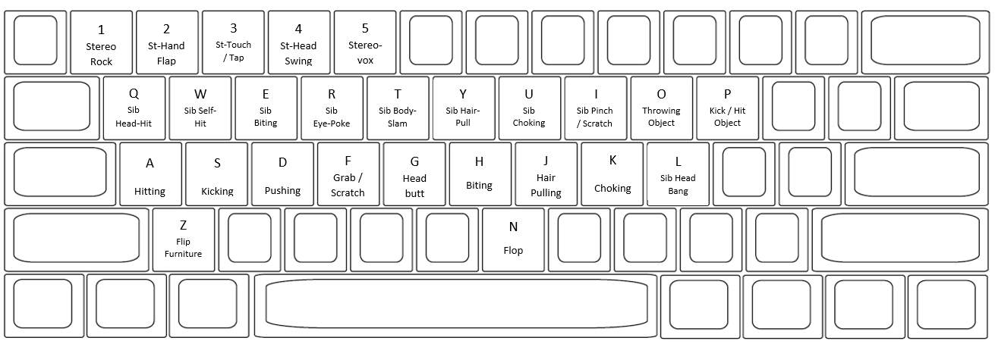

**\*\***For exact descriptions of each behavior, see **Operational Definitions** document

**\*\***See the **Coding Cheat-Sheet** for simplified descriptions of the behaviors and their keys

**Keyboard Close Up**

**Keyboard Codes**

**Section 8** E4 Streams

* **E4 Streams** tab displays physiological signals collected by the wristband

Body Temperature

Wristband Battery Life

Wristband Location

Heart Rate

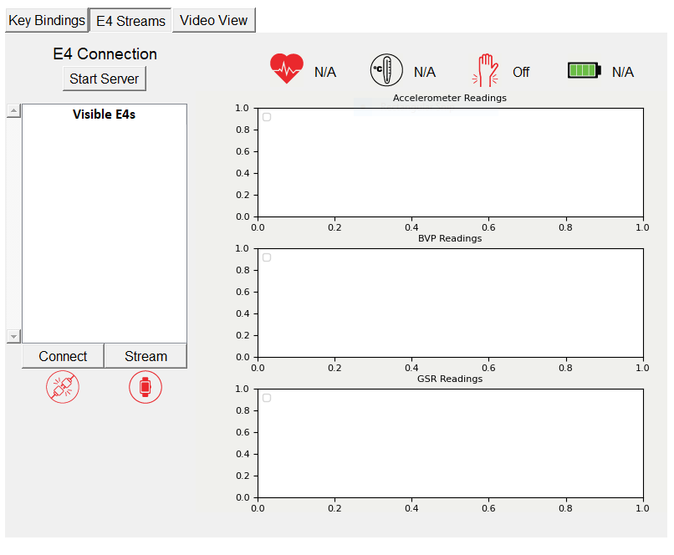

<https://developer.empatica.com/windows-streaming-server-usage.html>

To connect an Empatica E4 to cometrics, setup the Streaming Server as described in the above link before pressing “Start Server”

Connection status of wristband

Streaming status of wristband

**Section 8** E4 Streams



Select **Stream** to start streaming the data from the wristband to the cometrics program

The **Visible E4s** tab shows the available wristbands that can be used to stream data

Press **Start Server** to begin utilizing the E4 wristband

Select **Connect** to connect the wristwatch to the cometrics program

**Section 8** E4 Streams (Icons)

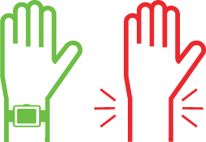

Wristband **on** arm

**Wristband Location**

Wristband **off** arm

≤ 100%

≤ 75%

≤ 50%

≤ 25%

**Battery Life**

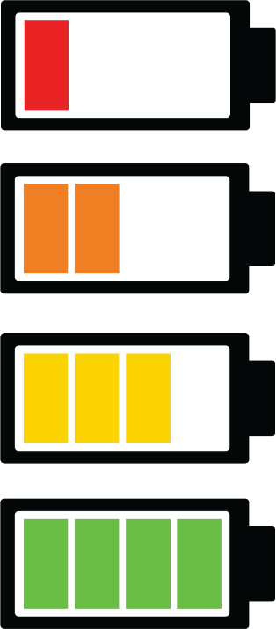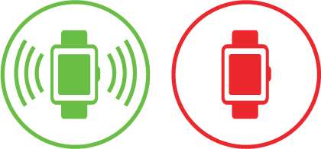

**Connection Status**

**Streaming Status**

Connected

Not connected

Not streaming

Streaming

**Section 9** Video View

To record from a connected **Webcam**, use the dropdown to select an input

The **Video View** window shows the video recording of the session

The **Load Video** button is used to select and upload the video you want to code

After pressing **Load Video**, locate the video file you wish to upload

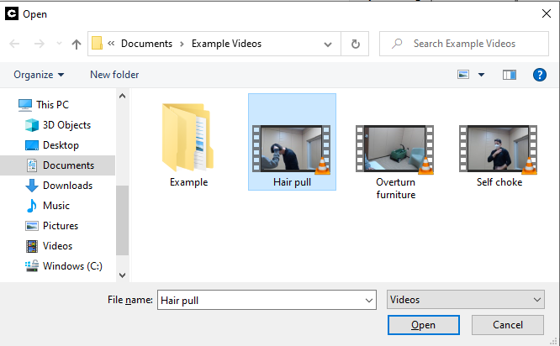

**Section 9** Video View

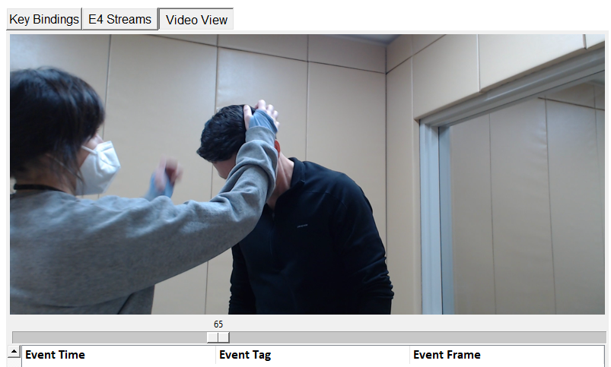

Selected video will upload and be viewable for coding

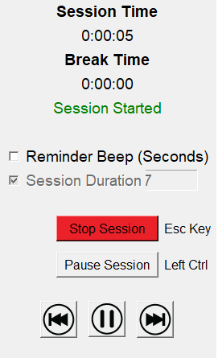

Used to go **Forward** in video by one second

Used to **Play / Pause** video

Used to go **Backward** in video by one second

**Section 9** Video View

When coding an uploaded video, the **Video View** tab will look like this. The individual codes given to the video are labeled by 3 characteristics: **Event Time, Event Tag, and Event Frame.**

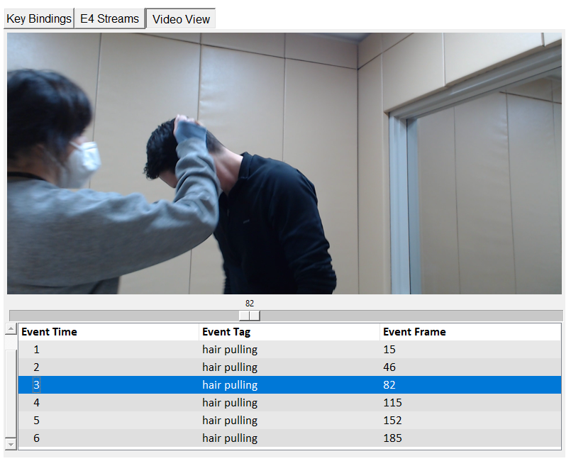

 **Section 9** Video View

Codes can be viewed underneath the **Video View** Tab

This example video has 189 total frames. The **Event Time** column breaks this down into 6 sections.

Events can be edited by double clicking an event. A popup window will open that allows the event to be changed using a dropdown.

The **Event Time** column breaks the video into more manageable sections. This makes it easier to recall the general time frame in which events occurred.

The **Event Tag** column shows the behavior assigned to the given code

The **Event Frame** tab shows the specific frame where the coded event begins

**Section 9** Video View

Selected cameras can be used to **view, record,** and **code** sessions **live**

Connected cameras can be selected for use in this tab

To turn on the **Webcam and Mic** or other connected camera, press **Select Camera** and choose the desired input and press **Select Microphone** and choose the desired input

The order of activation of connected **Webcams** is the order of the inputs on the camera dropdown menu

**Section 10** Quick Access Menu

**Start New Session** – Reset the coding UI with the same settings

**Open New Project** – Close the coding UI and restart cometrics

**Export CSV** –Used to export all existing session data for the patient into CSV files

**Analyze Sessions** – Plots the session history for the patient into their KSF

**Calculate Session Accuracy** – Calculate the interobserver metrics between two sessions

**Analyze tab:** Used to export view recorded data and calculate session accuracy

**Open Documentation** – Opens this guide using default PDF viewer

**Open Logs ­**– Opens the log file directory using File Explorer

**Open Current Directory** – Opens the working directory for the current patient

**Download E4 Streaming Server** – Opens the documentation for setting up the E4 Streaming Server and automatically downloads the same

**Open Source Code** – Opens the default web browser to the public GitHub page for the cometrics software package

**Submit Feedback** – Opens popup that collects feedback and sends it to the developer. This feedback will be posted as an Issue on the GitHub repository

**Section 11** Keystroke File Format

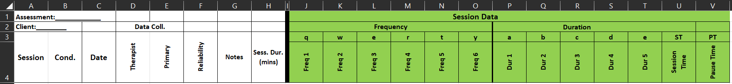

The keystroke file has a format that needs to be followed, an example of a working keystroke file can be found in the *references* folder of the root directory of the cometrics installation

The fields in the example keystroke file need to be present and when a new revision is created within the cometrics user interface, any custom fields or formatting are **not preserved**

**Section 12** Interobserver Agreement Coefficients

The calculation bin size can be adjusted in units of seconds, with 10 seconds as the default

Select which session will act as the primary session

When both sessions are selected the IOA coefficients can be calculated, the output file will be highlighted in the File Explorer

Select which session will act as the reliability session

The ‘Analyze’ tab in the menu bar will allow the user to calculate the interobserver agreement (IOA) coefficients between two sessions

Pressing this button will open the window to the right

**Section 12** Interobserver Agreement Coefficients

Frequency Keys Partial Interval Agreement Percentage (PIA)

For each interval, x = smaller value / larger value

If both reliability and primary have zero value, then x = 1

Partial Interval Agreement = average all x values * 100

Frequency Keys Occurrence Interval Agreement Percentage (OIA)

Given that one observer scored 1 or more for an interval, agreement if both scored at least 1

If both observers recorded zero responses, the interval is excluded

Occurrence Interval Agreement = agreements / (agreements + disagreements) * 100

Frequency Keys NonOccurrence Interval Agreement Percentage (NIA)

Given that one scored 0 for an interval, agreement if both scored 0

If both observers recorded at least one response in the interval, then the interval is excluded

NonOccurrence Interval Agreement = agreements / (agreements + disagreements) * 100

Frequency Keys Exact Agreement Percentage (EIA)

Agreement is scored if both primary and reli have same value for an interval.

Exact Agreement Percentage = total agreements / total intervals * 100

Frequency Keys Total Agreement Percentage (TIA)

Agreement = # of intervals where both scored zero or > 1

Total agreement = number of agreements / total intervals * 100

Duration Keys Partial Interval Agreement Percentage (PIA)

For each interval, x = smaller value / larger value

If both reli and primary have zero value, then x = 1

Partial Interval Agreement = the average of all x values * 100

Duration Keys Exact Interval Agreement Percentage (EIA)

For each interval the value of the primary and reli is rounded to the nearest second

Agreement is scored if both primary and reli have same value for an interval.

Exact Agreement Percentage = total agreements / total intervals * 100

**Section 13** Session Output File Format

Each session has an output file that lists all collected information during a session including the Patient Information fields, keystrokes logged with timestamps from the timer, E4 frame, and video frame, where applicable, as well as all E4 data organized into one second windows

The session file is in JSON format, which is a human-readable file that is easily parsed in various programming languages

The file can be opened and read in a text file editor, such as Notepad

Additionally, sessions can be converted to comma-separated value (CSV) format using the button in the ‘Export’ tab

**Section 14** Configuration Changes

In the root directory of the cometrics installation is a file called *config.yml*, which defines several control variables for the software

The above user interface allows the user to modify this file. The “FPS” field allows the user to change the frames per second on the webcam feed. Values up to 30 FPS have been used, but the max FPS is dependent on your camera.

The E4 checkbox enables the recording of Empatica E4 data. The Woodway checkbox enables the control of a Woodway Split Belt Treadmill. The BLE checkbox enables the control of a BLE peripheral device. The Review mode checkbox enables the Review Mode tab.

The A and B fields allow the input of the serial numbers of the Woodway Split Belt Treadmill.

The “Clear Recent Projects” will delete all the projects that are saved and shown during Project Setup.

**Section 15** Understanding Webcam Order

When cometrics starts up it will poll for all connected cameras, either integrated or connected via USB and the list indicated above will be populated with the cameras found

This order is the same each time given the same cameras being connected, but there is no way to differentiate between cameras

The user will have to evaluate each input to determine which camera is which input

**Section 16** Modifying Keystroke Files

**Key Tag** – The tag (behavior, label, etc.) that should be associated with hitting the specified key

**Key** – The key press that should trigger the recording of the specified tag

Pressing “OK” will add the key to the end of the displayed list

Pressing either of the two highlighted buttons will create a new key within the keystroke file

When a new key is created, the “Generate” button will be interactable and a popup will show

**Section 17** Connecting External Input

We used [this (Amazon Link)](https://www.amazon.com/gp/product/B084VTFS4X/ref=ppx_yo_dt_b_search_asin_title?ie=UTF8&psc=1) for development, similar buttons may work but no guarantee is made.

**External devices** can be added via **Bluetooth** for use during coding.   
Connected devices (clicker, mouse, etc.) can be used as an **external button**

* First, the user must **connect** the desired device to their computer **via Bluetooth**
* In the Windows search bar in the bottom left, search for “**Bluetooth and other devices settings**”
* Click to open system settings



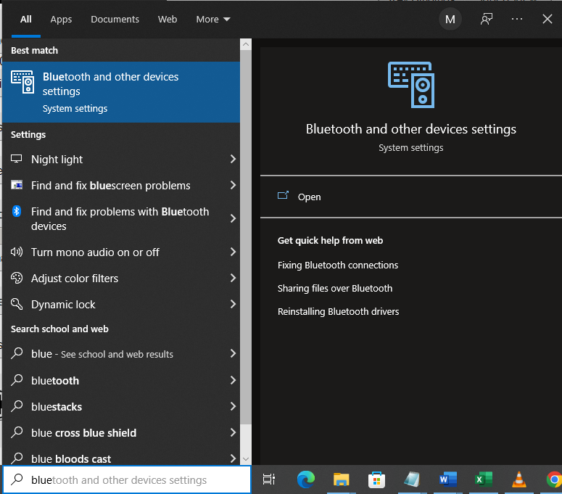

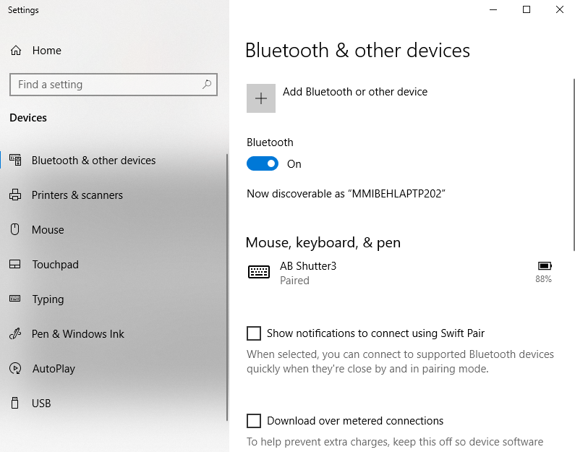

* The “Bluetooth and other devices” window will open
* Select “Add Bluetooth or other device”
* Make sure Bluetooth is turned on

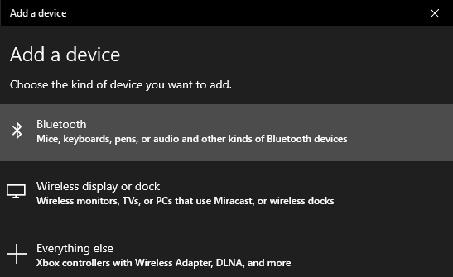

* The “Add a device” menu will open
* Select “Bluetooth” as the device type
* Find and select the desired device from the list of connectable devices
  + If the desired device is not listed, check that it is turned on / discoverable

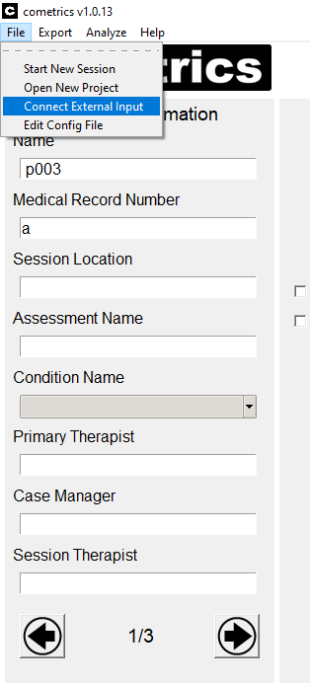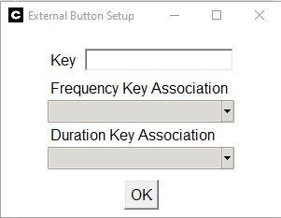

The “External Button Setup” menu will pop-up

Use the cursor to activate the “Key” input line. Press your external device to set it as the key

Select whether this button will be used as a Frequency key or a Duration Key

* + Select the specific behavior that will be assigned to the external button

To setup an external button in **cometrics**, select “File” in the top left-hand corner.

Select “Connect External Input”

**Section 18** Reporting Bugs and Other Issues (GitHub)

Bugs and other issues found while using the cometrics program can be reported through the Munroe Meyer Institute Virtual Reality Laboratory GitHub page. The steps for reporting a bug are as follows:

1. Create or login to a GitHub account

<https://github.com/login?return_to=https%3A%2F%2Fgithub.com%2Fjoin>

1. Use the following link to access the Issues section of the cometrics’ GitHub <https://github.com/Munroe-Meyer-Institute-VR-Laboratory/cometrics/issues>
2. 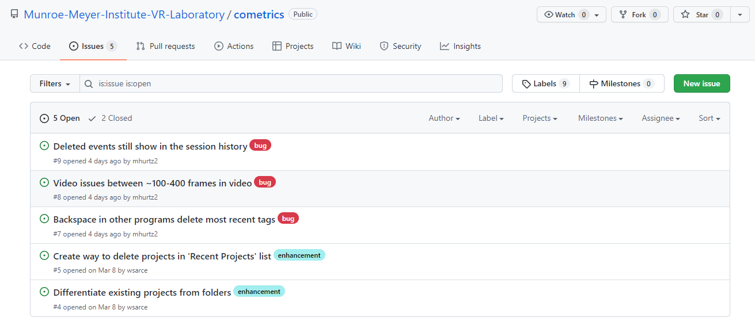Select the green “New Issue” button in the top right of the Issues page
   1. The Issues page is also used to view what bugs have already been reported, preventing repeated reports of the same bug
3. 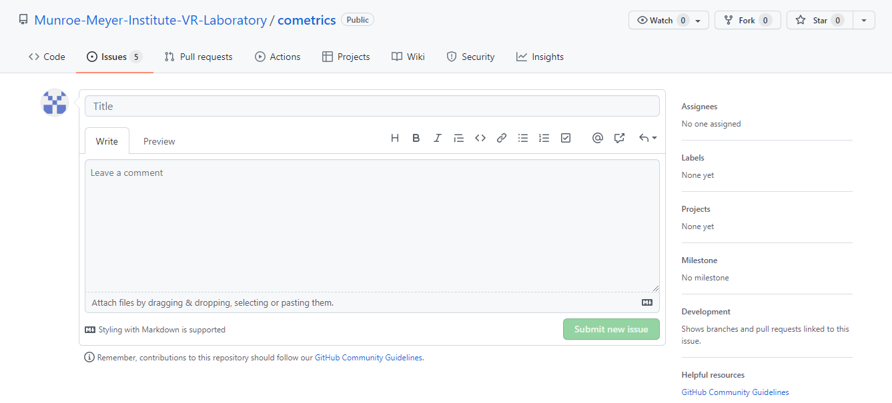The “Submit new Issue” page (pictured below) will open
4. In the “Title” section, provide a general description of the issue
5. In the “Leave a comment” section, write a detailed description of the issue (what happened, how it occurred, etc.)
6. Press the green “Submit new Issue” button in the bottom right to finalize bug report

**Section 19** Woodway Split-Belt Treadmill Support

Once connected to the Woodway, the belt speed and treadmill incline can be manually changed

Pressing **Calibrate Woodway Threshold** will open the window shown on next page

**Add** – Create a new protocol step  
**Delete** – Remove a selected protocol step  
**Load File** – Select a protocol file from filesystem  
**Save To File** – Save new revision of protocol  
**Connect** – Connect to Woodway treadmill  
**Disconnect** – Disconnect from Woodway treadmill  
**Edit** – Double click any protocol step to edit

**Section 19** Woodway Split-Belt Treadmill Support

Set the change in incline for the treadmill for this protocol step

Set the change in speed for the right belt for this protocol step

Set the change in speed for the left belt for this protocol step

Set the duration in seconds for new protocol step

Add the protocol step

**Section 19** Woodway Split-Belt Treadmill Support

Press **Calibrate** to start the calibration process and follow the directions

**Section 20** BLE Peripheral Support

Once connected to vibrotactors, the motor levels and frequency can be manually altered

Pressing **Calibrate Vibrotactor Threshold** will open the window shown on next page

**Add** – Create a new protocol step  
**Delete** – Remove a selected protocol step  
**Load File** – Select a protocol file from filesystem  
**Save To File** – Save new revision of protocol  
**Connect** – Connect to vibrotactors  
**Disconnect** – Disconnect from vibrotactors  
**Edit** – Double click any protocol step to edit

**Section 20** BLE Peripheral Support

Set the motor vibration level for the right vibrotactor array as a percentage of the threshold

Set the motor vibration level for the left vibrotactor array as a percentage of the threshold

Set the duration in seconds for new protocol step

Add the protocol step

**Section 20** BLE Peripheral Support

Press **Calibrate Left** to start the calibration process and follow the directions

**Section 21** Review Mode

**Review Mode** allows for recorded sessions to be expert validated.

The reviewer will put their name into the textbox.

The data type then will be selected and, if sessions exist, each session is selectable.

The status of the session (whether it’s been reviewed and by whom) is shown above the session number.

The arrows allow switching between sessions.

When the correct session is selected, press the ‘Load Session’ button.

All the events in that session are now selectable and load in automatically.

The keystroke associated with each event can be changed, though only one keystroke is allowed per session.

Pressing ‘Play Clip’ will show the video segment that has been selected as representing the selected keystroke.

The two textboxes below are the ‘To’ and ‘Frame’ entries and display the corresponding start and end frames of the video clip.

When an event is accepted or rejected, the changes made will be saved and the next event will be loaded.

Once all events have been either accepted or rejected, the session can be approved, which will mark is as ‘Reviewed’ and save the reviewer’s name with the session.

If a session is approved, the name of the reviewer will be shown along with a checkmark indicating approval.

**Section 22** Loading Previous Sessions

Previous sessions can be loaded by changing the session number in the Patient Information window. The session will be automatically loaded and the video file path will be assigned to the Video View panel so that when the Load Video button is clicked then the session video will load.

Edits to the events in the Video View event viewer will automatically save to the source session file so the session doesn’t need to be started to make simple changes.

Changing the session number will either load an existing session or, if a session does not exist, will clear the previous loaded session to allow standard operation.

**Section 23** Calculating E4 Metrics

Once completed, the output directory will be opened. The files are saved as CSV files in the Export directory of your current patient.

A utility has been built in to the ‘Analyze’ menu tab to calculate statistical metrics from your collected Empatica E4 data. Both the photoplethysmography (PPG) and electrodermal activity (EDA) are processed for analysis purposes. The metrics are calculated on a 20 second interval and the corresponding frequency and duration measures are binned.

The EDA metrics are the total number of peaks and the average amplitude of the signal during the 20 second interval.

The PPG metrics are the heart beats per minute and heart rate variability metrics.

**Section 24** Sending Feedback

When all fields are complete, press ‘Submit,’ and it is sent to the developer on GitHub

To open this user interface, press the ‘Submit Feedback’ button under the ‘Help’ menu bar.

Press ‘Cancel’ to close the window and lose any changes made to it

Select a label for this feedback

**Bug** – A problem or error encountered in the software

**Enhancement** – A suggestion to improve the software

**Documentation** – When a function of cometrics is not well-defined

Enter a description for your feedback, the more detail added the easier it will be to address!

Feedback messages need a title, make it descriptive and simple.

In cometrics v1.3.0, a new user interface is available that allows an anonymous user to submit feedback.